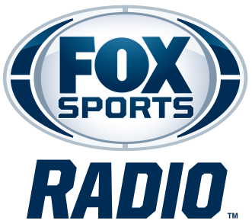

LAVAR ARRINGON
BIOGRAPHY

LaVar Arrington is co-host of FOX Sports Radio’s weekday morning program, 2 Pros and a Cup of Joe with Brady Quinn and Jonas Knox. Airing Monday through Friday from 6 to 9 a.m. ET on more than 350 stations nationwide, in addition to iHeartRadio, the program features the trio’s entertaining and thought-provoking conversation on the biggest headlines.
Arrington is also co-host of FOX Sports Radio’s national weekend show and podcast “Up On Game,” along with TJ Houshmandzadeh and Plaxico Burress. Each week on the program, the trio takes on the latest hard-hitting sports topics for athletes, while welcoming guests from the world of sports and entertainment. Utilizing their vast knowledge of football, the hosts aim to educate, inspire and entertain listeners and athletes of all ages, sharing their real-life experiences and stories, teachable moments and candid discussions that help players improve their game and perform at the highest level.
The program broadcasts live on Saturdays from 1 - 3 p.m. ET on 400 radio stations around the country, in addition to streaming live on the FOX Sports Radio channel on iHeartRadio, and being available weekly as a podcast on iHeartRadio and other platforms.
Arrington previously co-hosted FSR’s nationally syndicated “FOX Sports Sunday with Mike Harmon.” He first joined FSR as a weekend personality in February 2020. Prior to that, he hosted a radio program on WJFK-FM in Washington, D.C. for several years. During that time, he produced a multimedia blog for The Washington Post. In addition to his current radio duties, Arrington is a regular contributor to FS1.
A Former Penn State All-American Linebacker, Arrington was the #2 pick in the 2000 NFL Draft. The three-time Pro Bowler played for the Washington Football Team from 2000 to 2005. He later joined the New York Giants before retiring in 2007.
# # #

